Washington Township Green Team Meeting Agenda
Monday April 2nd 2018 6:30pm
Washington Township Municipal Building
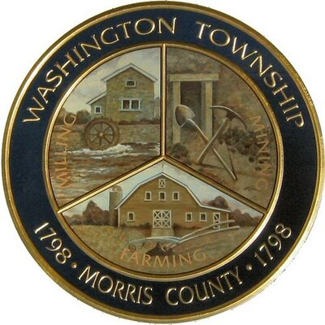

Members Present: __x_Chairman Dan Ross _x__Member Paula Ross, _x__Member Patricia Homer _x_Committee Liaison Ken Short___Gregg Forsbrey _____Bill Leavens
Others Present: __ x __ EC Member Valerie Walsh ___Town Administrator Andrew Coppola

6:30pm Meeting Call to Order

6:35-6:45pm Approval of March 2018 Minutes.

6:45-7:10pm Old Business; Final steps at Harrington Park, remaining deliverables, and upcoming spring workday rescheduling. Ideas for next undertaking?

7:10-7:35pm Progress on the TREX Challenge? New Developments on Green Market? Updates on SJ initiatives?

7:35-8:00pm- Clean Communities Week, Green Festival Updates. Potential new vendors/ sponsors?

8:00-8:15pm- Fundraising- New ideas? New grants available?

8:15-8:30pm- Open discussion, Membership, Outreach Updates on Social Media Page?

