Notre Dame of Mt. Carmel
75 Ridgedale Avenue, Cedar Knolls, NJ 07927
&
Basking Ridge Presbyterian Church
1 East Oak St., Basking Ridge, NJ 07920

Do you have a loved one struggling with alcohol or drug use?

Welcome to the

Family Support & Recovery Group
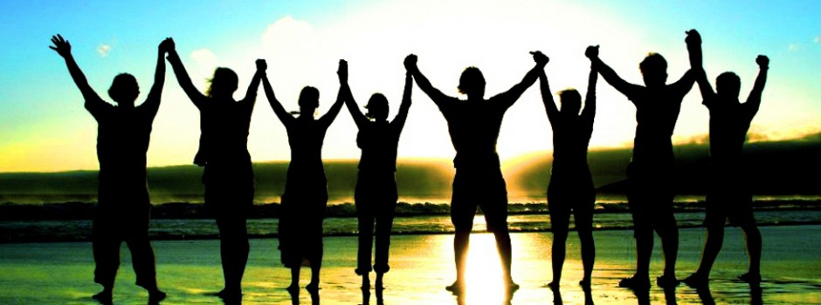
Hosted by Aussem Counseling & Wellness, LLC

1st and 3rd Thursdays of the Month at 7:30 to 9:00 PM at Notre Dame Upper Room
2nd & 4th Thursdays of the month at 7:00 to 8:30 PM at BRPC’s Parlor
A Sampling of Group Topics:

- The Science of Addiction – “Is it a rite of passage in teen years?” “Why doesn’t she just quit?”
- Stages of Change – “Can he really change or do I just have to wait for him to hit bottom?”
- Consequences as a Teacher – “Should I tell her coach?” “Should I kick him out?”
- One Size Does Not Fit All – “What are treatment options?”
- The Mental Health Parity and Addiction Equality Act – “Will insurance pay or do I have to mortgage my house to cover treatment?”
- The Toolbox – “Are there better ways to communicate and problem solve?” “What if I’m not on the same page as my spouse/partner?”
- Managing Emotions – “What do I do with my fear, anger and anxiety?”

There will also be time to discuss and process issues or concerns
in each session. Please note there is no fee for the sessions. For additional information please contact Pat Aussem, LPC, MAC at 973-355-6604 or via email at pataussem@gmail.com.

