Washington Township Green Team Meeting Agenda
Monday October 1st 2018 6:30pm
Washington Township Municipal Building
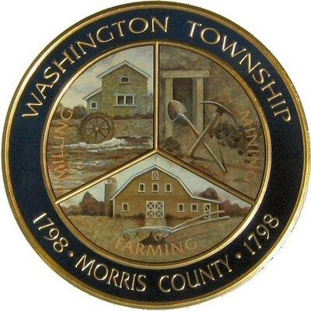

Members Present: __x_Chairman Dan Ross _x__Member Paula Ross, ___Member Patricia Homer __Committee Liaison Ken Short_x_Township Committeeman Gregg Forsbrey ____ Member Valerie Walsh
Others Present: ___Town Administrator Andrew Coppola __x_David Belsky _x__Denise Spina-Belsky
6:30 pm Meeting Call to Order
6:35-6:45pm Guest Speaker: Merv Haines WTEC- Chestnut Grove Introduction.
Old Business;
Green Festival
- What worked, what didn’t and why?
- List of our final vendors/ exhibitors
- Suggestions or thoughts for next year?
6:45-7:00pm New Business:
Market at Long Valley
- Ordering of new signs for remainder and next year.
- T-shirts? thoughts ideas, and thank you to our vendors?
- Looking ahead to next year, advertising? Sponsors?
- Suggestions for the new Market Committee?
7:00-7:15 pm
Harrington Meadow
- Looking forward to fall seeding
- Installing the new benches?
- Dedication ceremony?

7:15-7:30pm-
Updates to Mission Statement/ Position Nominations
- Suggested changes, or thoughts?
- Floor vote on suggested changes.
- Review of the expenses report (Paula)

7:30-8:00pm
Miscellaneous:
- Upcoming initiatives, clean communities dates/ sign up
- Outreach and communications updates?
- Fundraising and new membership?

Call to adjourn: 8:45pm

