Washington Township Green Team Meeting Agenda
Monday December 4th 2017 6:30pm
Washington Township Municipal Building
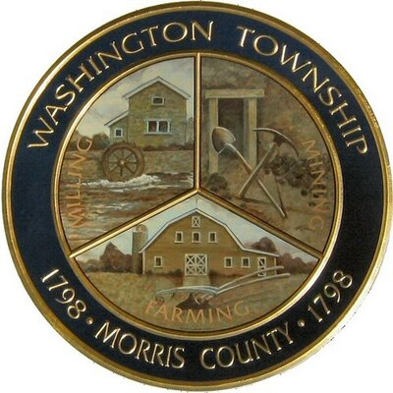

Members Present: __x_Chairman Dan Ross _x__Member Paula Ross, ___Member Patricia Homer __x_Committee Liaison Gregg Forsbrey
Others Present: __x__ EC Member Valerie Walsh __x_Town Administrator Andrew Coppolla

6:30pm Meeting Call to Order

6:35-6:40pm Approval of November 6th 2017 Minutes.

6:45-7:10pm Progress at Harrington Park, and next steps looking towards the spring.

7:10-7:35pm Sustainable Jersey, where we stand, and available actions.

7:35-8:00pm New members, official appointments, fundraising, spring activities, and open discussion

8:00pm Motion to Adjourn.

