Washington Township Green Team Meeting Agenda
Monday June 4th 2018 6:30pm
Washington Township Municipal Building
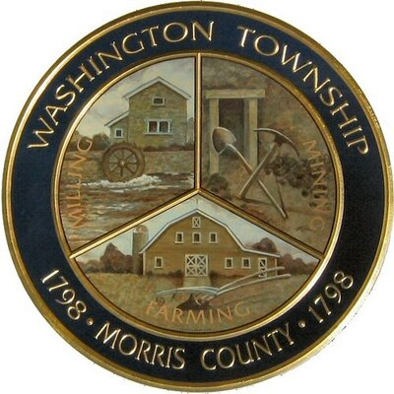

Members Present: __x_Chairman Dan Ross _x__Member Paula Ross, __x_Member Patricia Homer __Committee Liaison Ken Short_x_Gregg Forsbrey __x___Bill Leavens
Others Present: __x__ EC Member Valerie Walsh _x__Town Administrator Andrew Coppola __x___Economic Development Committee Chair Tyler Oborn
6:30pm Meeting Call to Order
6:35-7:10pm Old Business;
Harrington Fields Pollinator Meadow
- Final Report to ANJEC re: Harrington Park and grant extension for next steps.
- Updates on signage, need to discuss setting up an installation date with DPW.
- Planning for an additional workday to plant plugs once purchased.
- Call for meadow plant donations/ looking ahead to interpretative trail work.
TREX Challenge
- Updates on status, and ideas for anything similar?
7:10-7:45pm New Business:
Green Market
- Updates and moving forward with partnering with the Economic Development Committee.
- Addressing any new obstacles or barriers to progress, mitigating concerns
- Involvement of the township, trash disposal, mowing, field access, parking spot designations, creating signage and flyers for promotion. Access to LVFAS display? Reaching out to vendors.
Green Festival
- Updates. Potential new vendors?
- Sponsors, more information on Brew Pub from Gregg?
- Work on the Passport game and Trivia Quiz (Patty)
- Discussion of potential theme or prizes?

7:45-8:00pm- Upcoming initiatives:
- Release of Lawn Grass Clippings Mulching and Composting Flyers for SJ points
- Working with the Ad Hoc Trails Committee on implementing the interpretative path.
- Possible partnership with the LVMS on front rain garden?
- Fall Clean Communities Week/ Paper Shredding event.
- New opportunities to collaborate?
8:00-8:15pm- Miscellaneous:
- Fundraising- New ideas? Any new grants available?
8:15-8:30pm- Open discussion:
- Increasing membership, Bolstering Outreach, Updates on Social Media Page?
- Administrative: Approval of May 2018 Minutes.

