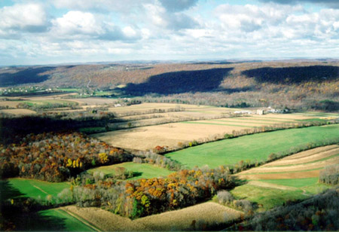

Washington Township Municipal Bldg.

43 Schooley’s Mountain Road

Long Valley NJ 07853

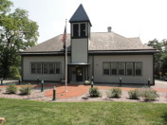

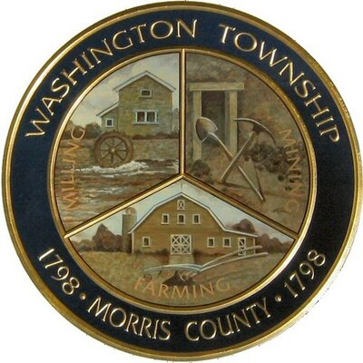

### http://www.wtfdmorris.org/images/wtmap.jpg



Phone: 908-876-3652

Fax: 908-876-5138

www.wtmorris.org

Washington Township

Morris County New Jersey

Board of Adjustment

**THE BOARD OF ADJUSTMENT PROCESS**

**Schedule a Meeting**

Schedule a meeting with the Board Administrator to advise you regarding the Board of Adjustment procedures, application and materials needed for submission, fees involved, and answer any questions.

Information Needed:

• Street address of property &

Block/Lot address

• Detailed plan

• Property Survey (certified by a NJ

Licensed Professional Land Surveyor)

**Submit an Application**

When the specific request is determined, a formal application is submitted to the Board of Adjustment which includes the following:

1. A detailed statement of the applicant’s intent regarding the subject property.

2. A detailed plan showing all existing and proposed buildings, paved areas, and utilities. The plan must include dimensions of parcel of land, dimensions of existing structures and/or proposed structures including setbacks (distances from property lines).

3. Application documents and checklist.

4. Fees:

“C” Variance (Residential): Application - $250 Escrow - $500

“C” Variance (Non-residential): Application - $500 Escrow - $1000

“D” Variance: Application - $750 Escrow - $2000

Appeal: Application - $100 Escrow - $1000

5. The application will be reviewed by the Board Administrator and Engineer for completeness before it is scheduled for a public hearing.

**Public Hearing**

Notice is to be sent out to property owners within 200 feet of the subject property (a list obtained through the Tax Assessor) and placed in the officially recognized newspaper.

The Board of Adjustment’s decision making process is similar to that of a court hearing. It will hear evidence presented from opponents, proponents and its professionals, then issue a decision.

All parties that speak are required by state statute to be sworn in. The property owner or his/her agent, who must be present at the meeting, can explain plans for the property including a description of its proposed use(s). Anyone wishing to speak at the hearing may do so when the

Chairman indicates it is time to receive public comment.

The case hearing is not to solicit broad public opinion about how the board should vote on a matter; rather, it is a time for submittal of relevant factual evidence into the record by applicants, the public, and the Board’s professionals.



The Board of Adjustment is a "quasi-judicial” administrative body appointed to maintain and interpret the Zoning Ordinance and related policies for specific cases. The Board of Adjustment performs the following duties:

**Appeals**

The Board of Adjustment has the duty to hear and decide appeals from and review any order, requirement, decision or determination made by the Zoning Officer.

**Variances**

Board of Adjustment may grant a variance in certain situations that enables a property owner to make use of the property in some way that conflicts with the provisions of the ordinance. Variances can be granted for relief from bulk requirements such as required setbacks. These are called “C” Variances. Variances can be granted for relief from the permitted uses for the particular zone that property is located. These are called “D” Variances.

The Board of Adjustment consists of 7 voting members and 2 alternate members.

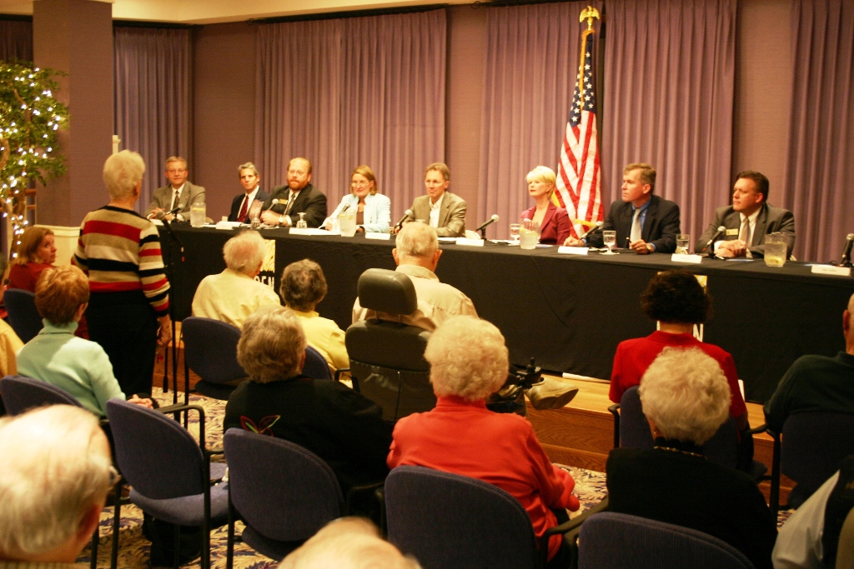

### What is the Board of Adjustment?