Washington Township Green Team Meeting Agenda
Monday May 7th 2018 6:30pm
Washington Township Municipal Building
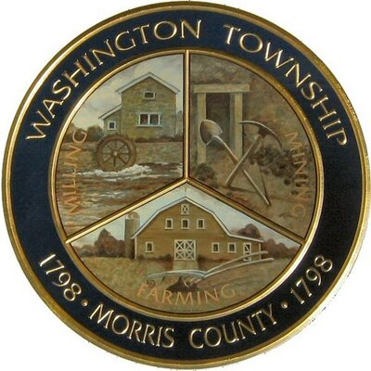

Members Present: __x_Chairman Dan Ross _x__Member Paula Ross, ___Member Patricia Homer _x_Committee Liaison Ken Short_x_Gregg Forsbrey _____Bill Leavens
Others Present: ____ EC Member Valerie Walsh _x__Town Administrator Andrew Coppola
6:30pm Meeting Called to Order
6:35-6:45pm Approval of April 2018 Minutes.
6:45-7:10pm Old Business;
- Reporting back to ANJEC about Harrington Park, remaining deliverables.
- Updates on brochure holders, and signage, progress on DPW signs?
- Promoting the official opening ceremony/ butterfly release.
- Ideas for next undertaking?
7:10-7:35pm New Business:
- Progress on the TREX Challenge.
- Updates on Green Market, and moving forward with partnering with the Economic Development Committee.
- Updates on SJ initiatives, including next steps, and additional initiatives we might wish to undertake.
- Green Festival Updates. Potential new vendors/ sponsors?

7:35-8:00pm- Past town wide initiatives:
- Clean Communities Week/ Paper Shredding event.
8:00-8:15pm- Fundraising- New ideas? New grants available?
8:15-8:30pm- Open discussion, Membership, Outreach Updates on Social Media Page?

